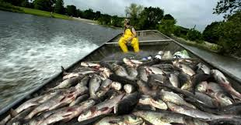
Tournament will be held on Kentucky Lake
Saturday June 9, 2018
Entry of $500.00 per BOAT (2 person team)
First FIFTY registered get a FREE event T-shirt and goody bag
Launch time is 6 A.M. from your favorite launch area on KY. Lake and final weigh in will be at 4 P.M. at:
Almost Home RV Park
265 Rice Lane Springville, Tennessee 38256
615-289-5641
NO COMMERCIAL FISHING ALLOWED
This is for anglers that use conventional tackle, Dip nets or Cast nets.
NO LIMIT ON ASIAN CARP
The MOST weight per team WINS!!
Limit two person teams per boat.
For more details and to register and make payment visit:
www.almosthomervpark.com
1st place $100,000.00
2nd place $50,000.00
3rd place $20,000.00
4th place 2500.00 5th place 2000.00
6th place 1500.00 7th place 1000.00
8th place 700.00 9th place 500.00
10th place $400.00 Big Fish $5,000.00
*prizes, raffles, silent action, etc. day of event*CONCESSION’S Available
Based on 500 boat entered for prize amounts. Angler meeting
Friday June 8 @ 6 PM at Almost Home RV Park
Total prize money is subject to change if minimum boat requirements for event are not made. No cancelations or refunds.
No entry day of event. You must be preregistered for event in advance. Registration must be in by June 4, 2018 before event Rain or Shine

